## BPI View:

### PR View:

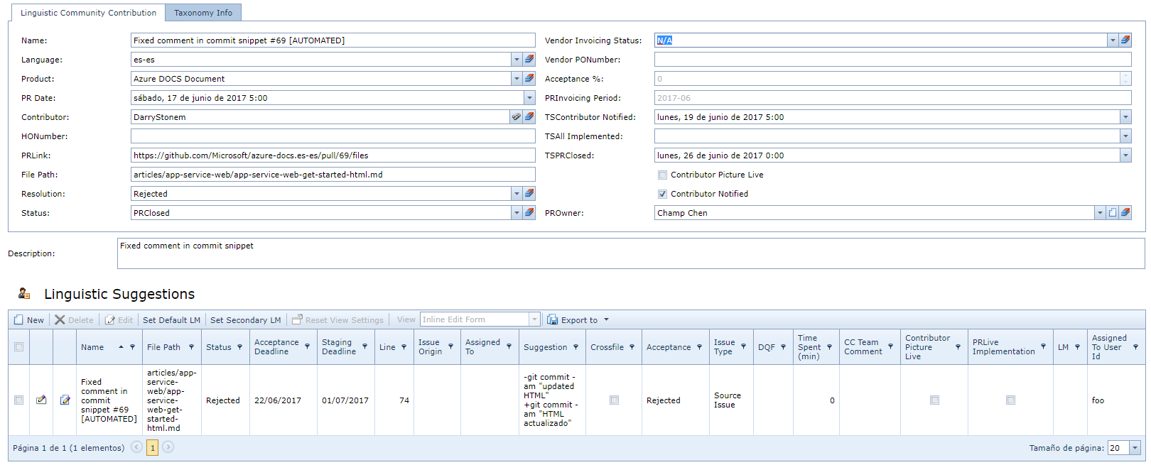

### Linguistic Suggestion View:

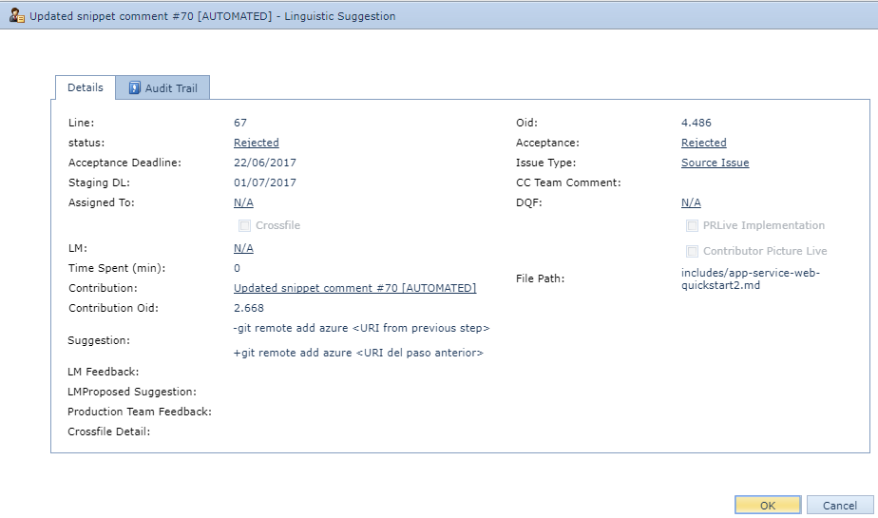

1. BPI automatically import the new PR with all highlighted suggestions from GitHub.
   1. By default, the PR Resolution is in “Pending” and status is on “Open” at PR level
2. CC Eng. will update and triage all imported suggestions.
   1. Update the Suggestion Status. By default, is on “created”
   2. “Acceptance” and “Issue type” by default are as “Pending”.
   3. DQF taxonomy is empty

## PR Level Status Machine:

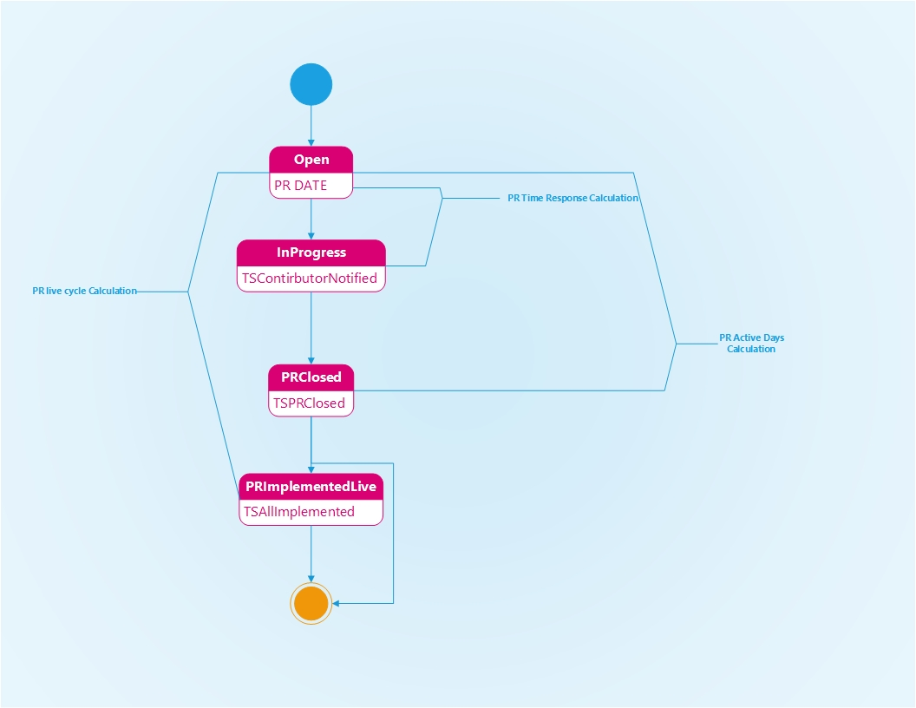

## Suggestion Level Status Machine:

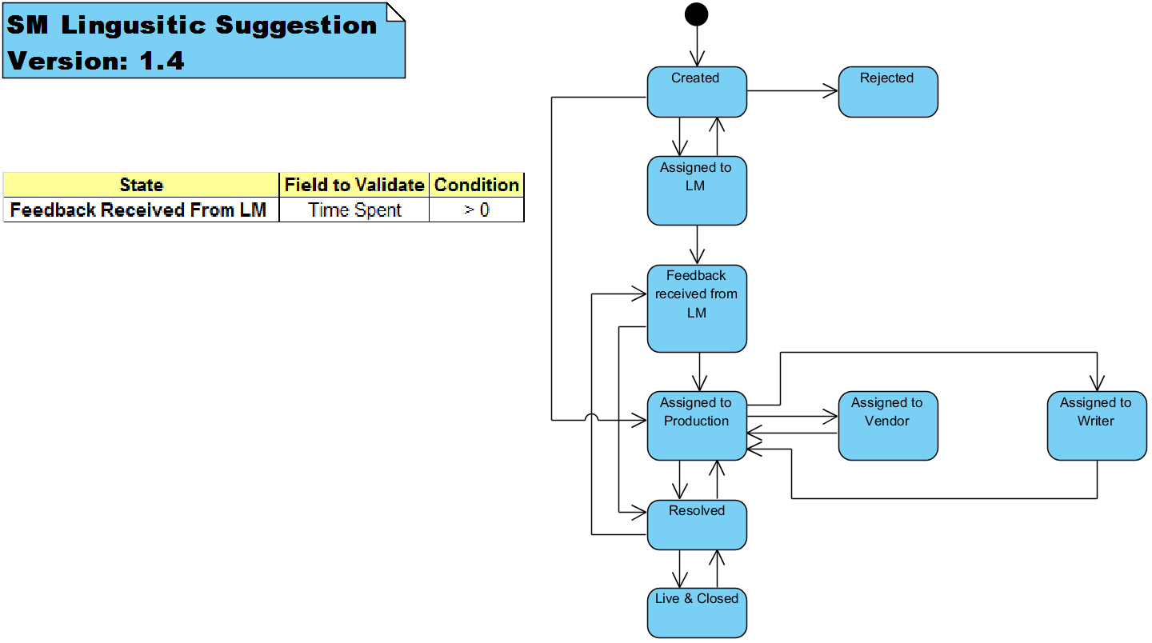

# Scenario 1: PR with Single Suggestion – Rejected

<https://github.com/Microsoft/azure-docs.es-es/pull/69/files>

## Suggestion created by contributor:



## Template Comments by CC Eng. Team.

